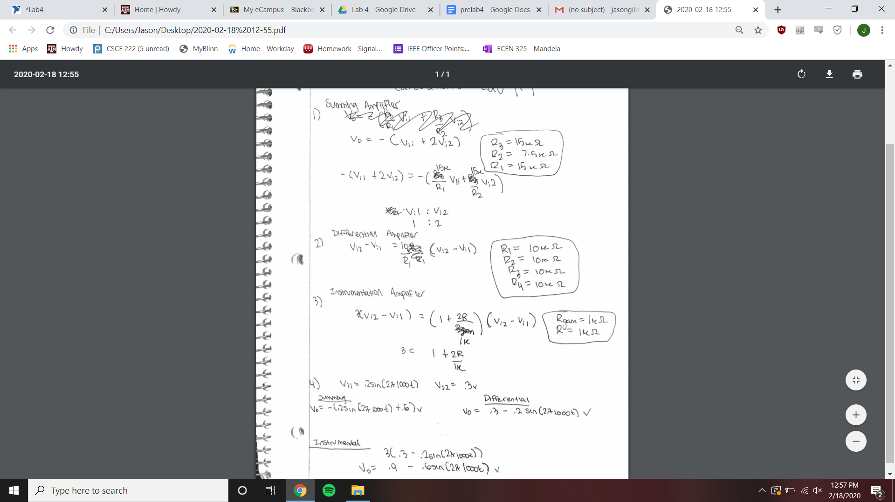

Schematics

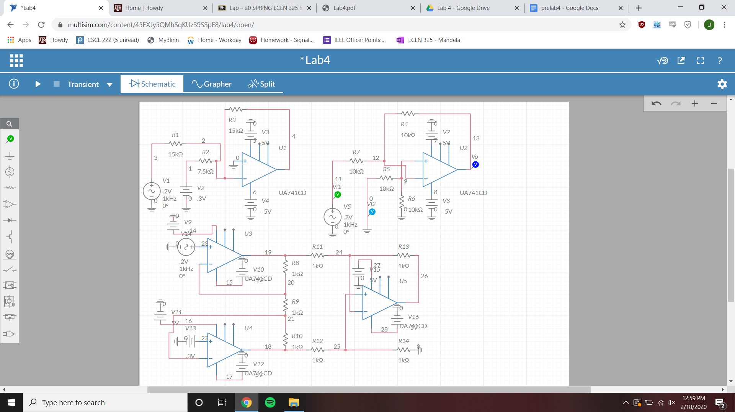

Summing Amplifier Time Domain plot

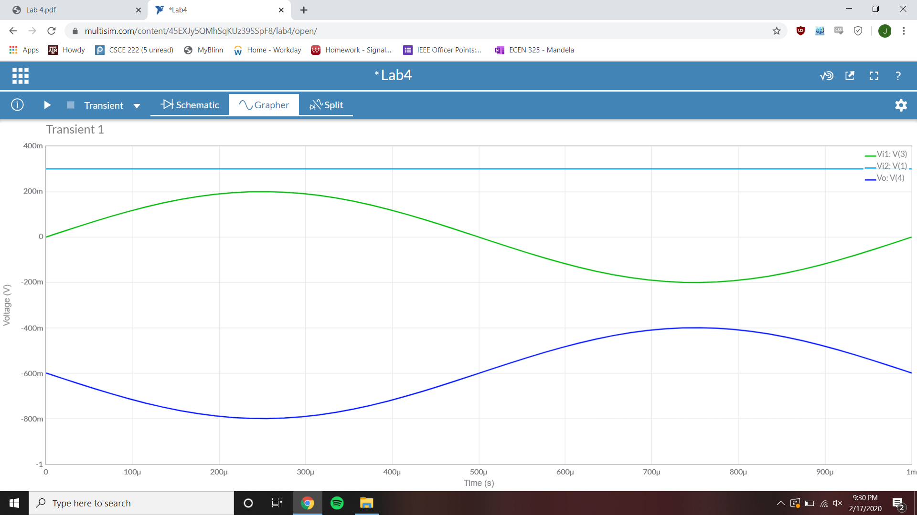

Vi1 Amplitude = .2 V Vi2 Amplitude = .3 V Vo Amplitude = .2 V

Differential Amplifier Time Domain plot

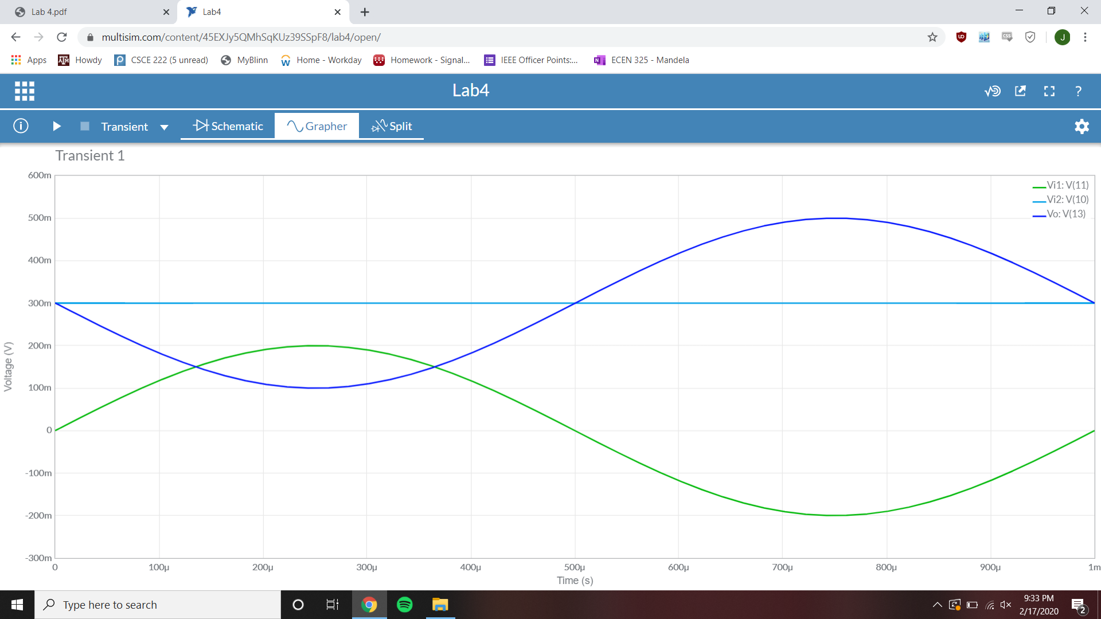

Vi1 Amplitude = .2 V Vi2 Amplitude = .3 V Vo Amplitude = .2 V

Instrumentation Amplifier Time Domain plot

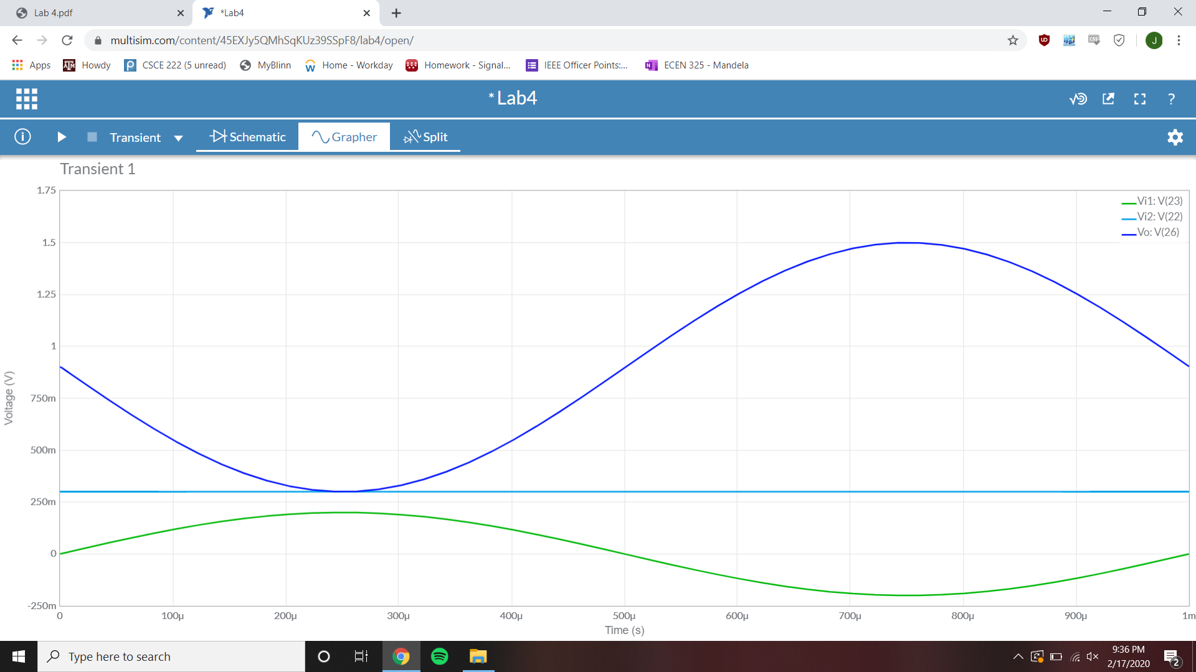

Vi1 Amplitude = .2 V Vi2 Amplitude = .3 V Vo Amplitude = .6 V